Benny the Bug
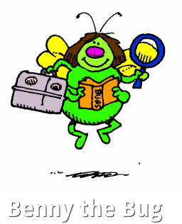

Who is he?
Benny is a bug with an adventurous little mind and a great imagination.

Benny’s Life Story

Benny grew up at the bottom of my garden with all his brothers and sisters. At the age of seven, Benny decided to go on an adventure so he set off to Castletown. On his way he met Danny the Dragonfly. Danny said, “Are you going to Castletown?” Benny said, “Yes I am”. When Benny got to Castletown he and Danny played all day.

When it got dark, Benny said goodbye to Danny. Soon Benny decided it was time to get a job so he flew around Celbridge looking for a place to set up his Bug Hotel.

He picked a lovely spot in Scoil na Mainistreach where he set up his Bug Hotel. The Hotel is surrounded by lots of trees and bushes and has a great view of the school. Benny welcomed his first guest, Wendy the Worm on 22 January 2014. This hotel is now rated 5 star.
By Darragh Kennedy
Ms Fleming – 3rd Class

