Benny the Bug
Hi my name is Benny, Benny the Bug.
I’m a ladybird my Mam is a carpenter
and my dad is in the army.
We moved house when I was 478 it was hard.
World War 1 was about to start to get violent.
So my Mom and Dad sent me in a space ship here.
I looked at my flyphone and it said
location Scoil Na Mainistreach.
Then a voice on my flyphone
said [welcome to the 5 star hotel,,
The bug Hotel.]
Anything you need my friend.
Then I said I would love a double bed, Jacuzzi [full of money], a swimming pool, a fridge full of slugs, a plasma TV the size of the wall and to make me feel at home a butler.
Then I said how much will that cost.
He said don’t you know everything here is free.
Benny the bug went blank for 5 minutes 32 seconds and 12 mille seconds. ‘’Could you get the Xbox 1, thanks’’ I said.
Ok he said that will all be up in 5 minutes. Then my Mam and Dad sent me a letter. Saying:
Dear Benny how are you. Would you like to come home, will we come to visit you?
From Mammy Jane
But Benny doesn’t want to go home because he had lots of friends.
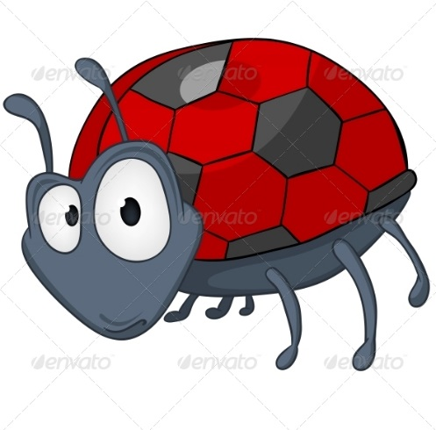After four weeks the war ended. Benny got a letter that put him under a lot of pressure.

It said, Dear Benny get out of Celbridge quickly. The war is over but they are heading to Celbridge. So get on a plane out of there. P.S hope you don’t die. From mammy Jane
He took a bus back from Dublin town, packed up, headed off to the airport and got on a plane [with a bomb] on it.
Benny didn’t know and unfortunately
It exploded and Benny died.
The End.

